Quick Setup Guide for Four Chambered Heart
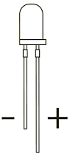 | 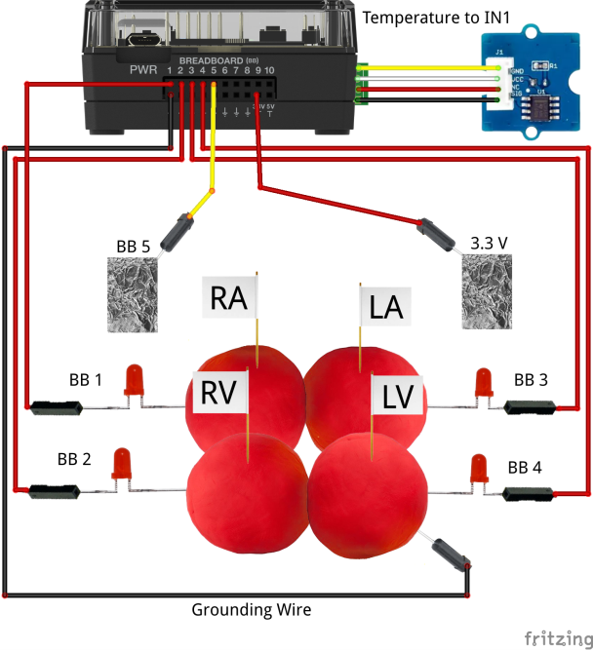
Build the Heart:
- Play-Doh material is conductive due to the salt and water content. Be sure the LEDs are inserted with the short anode (-) lead into the Play-Doh and the long cathode (+) lead in the receptacle of the jumper wire.
- Bend the LEDs leads at right angles and insert into chambers. Do not the (+) anode wire touch the Play-doh.
- The grounding wire may be plugged into any of the four Play-Doh chambers.
- Connect the pin of the LED jumper wires into BB1, BB2, BB3, and BB4. The order of chamber filling should be modeled in the same order as the LED blinking within the program, i.e. the LED connected to the right atrium should fire first (BB1) and the LED connected to the left ventricle should fire last (BB4).
- Be sure all four of the chambers are touching to make electrical connection.
- Insert a Grove temperature module into IN 1

Build the AED paddles:
- Aluminum foil attached to the lead of a M/M (male-male) jumper wire.
- A small piece of tape may be used to ensure good electrical contact between the wire pin and the foil.
- Fold the foil over a few times to make a rigid paddle.
- Paddle should be about one square inch
- Once paddles are constructed, plug one paddle into the 3.3V of the breadboard connector and the other into B

Troubleshooting:
- Are the LEDs oriented correctly? The long lead should go into the receptacle of a jumper wire and the opposite pin of the same jumper wire should be plugged into one of the BB ports 1 through 4.
- Are you using a conductive Play-doh? Some Play-Doh substitutes, e.g. plasticine or modeling clay, are not conductive and will not work. If you make your own, there are lots of recopies on the internet, add some extra salt to mixture to increase its conductivity.
- Check that the grounding wire is connected to any of the bottom row ground ports and the opposite end is in one of the chambers.
- Are the four chambers touching? The four chambers must touch to conduct electrically back to the ground wire.
- Is the anode (+) touching the Play-Doh? If both the anode and cathode leads are touching the Play-Doh, the circuit is shorted and will not work. This can occur if the LED is pushed too far into the Play-Doh.
- Check each LED circuit individually by unplugging from the BB port and plugging directly into the 3.3V breadboard port. The LED should light up.
- Once you know that each of the four circuits is working from step 6. Try writing a simple program that turns on each LED.

