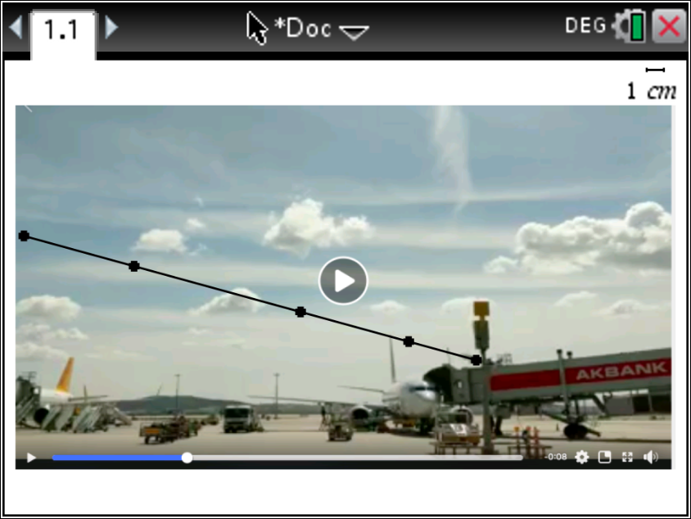

Lesson 1

Show the lift off video and asks the velocity of the plane

Role of Math Teacher
Provoke the students to collect data for the graph of Dist/time Vel/time and Acc/time

Role of Physics teacher
Supports math teacher with the concept of Acc,velocity….etc

Toola can used
Tı calculator -Spread sheet – regressions –

Lesson2
Role Physics teacher

Further more
Vector analysis with force of Gravity, Force air friction, Motor force and Lift force

Math Teacher
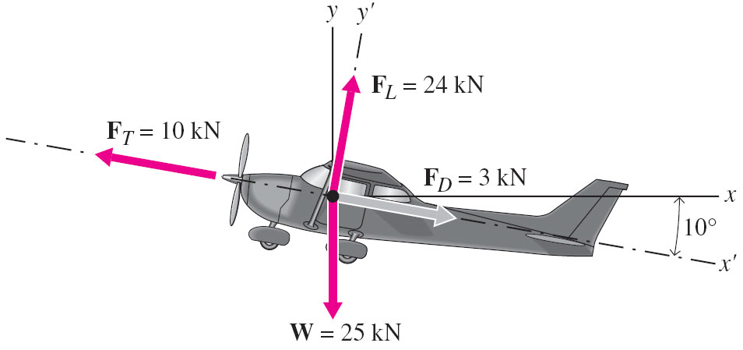
Support with the concept vector and operation on vectors …etc
Ft = motor force, W is gravitational force (m.g), Fl is lift force (perpendicular to path of the plane and the wings, Fd drag (air resistance). If a plane has no acceleration all the force has to balance each other. Compare with forces on a skier.
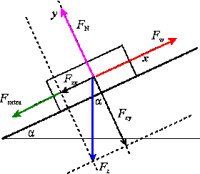

Lessson3
Design of the wings
Subtitles – economy of the flight, explanation of turbulence …etc

